

A REAL TIME FRAUD DETECTION SYSTEM IN DIGITAL
TRANSACTIONS USING MACHINE LEARNING FOR FINTECH
APPLICATIONS

BY

MCCARTHY OLATUNDE RAPHAEL 22/0930
BAMIGBOYE ENOCH AYOMIDE 22/2828
NJIDEOFOR MICHAEL CHUKWUEBUKA 22/2890

A PROJECT WORK SUBMITTED IN PARTIAL FULFILMENT OF THE
REQUIREMENTS FOR THE AWARD OF BACHELOR OF SCIENCE
B.Sc. (HONS) IN COMPUTER SCIENCE
SUBMITTED TO:

THE DEPARTMENT OF COMPUTER SCIENCE SCHOOL OF
COMPUTING, BABCOCK UNIVERSITY, ILISHAN-REMO
OGUN STATE, NIGERIA.

MARCH 2026

DECLARATION
We declare that the project work, “A REAL TIME FRAUD DETECTION SYSTEM IN
DIGITAL TRANSACTIONS USING MACHINE LEARING FOR FINTEH APPLICATIONS” was carried out by the following people:

MCCARTHY OLATUNDE RAPHAEL 22/0930
_______________________________________

BAMIGBOYE ENOCH AYOMIDE 22/2828

NJIDEOFOR MICHAEL CHUKWUEBUKA 22/2890

CERTIFICATION
I certify that this project was carried out by the following students under my supervision in the Department of Computer Science, Babcock University, Ilishan-Remo, Ogun State, Nigeria.

MCCARTHY OLATUNDE RAPHAEL 22/0930
BAMIGBOYE ENOCH AYOMIDE 22/2828
NJIDEOFOR MICHAEL CHUKWUEBUKA 22/2890

_______________________ ____________________
DR. ERNEST ONUIRI DATE
(PROJECT SUPERVISOR)

_______________________ _____________________
EXTERNAL EXAMINER DATE

_______________________ ____________________
DR. EBIESUWA SEUN DATE
(HEAD OF COMPUTER SCIENCE DEPARTMENT)

DEDICATION
This project is dedicated to the Lord Almighty, without his guidance, wisdom and protection none of us this would be possible. To our parents, relatives and friends for their support and love which kept us going throughout this journey.

ACKNOWLEDGMENT
We would like to give God all the glory for bringing us thus far in our academic endeavors. He is the source of all life and the one who kept us going during the project. We really appreciate Dr. Ernest, our project supervisor for helping us with this project's writing and providing guidance.
Finally, a heartfelt thank you to our friends and relatives. Their relentless encouragement and advice throughout this project journey were a constant source of support.
ABSTRACT
The rapid growth of digital financial services and online payment platforms has led to an alarming increase in fraudulent activities, threatening the stability, security, and credibility of financial technology (FinTech) systems. Traditional fraud detection methods, which depend largely on manual reviews and fixed rule-based mechanisms, are no longer effective in addressing the complex and evolving nature of modern fraud schemes. This study focuses on the design and implementation of a real-time fraud detection system that leverages machine learning (ML) techniques to identify and prevent suspicious transactions as they occur. Using an experimental research design, transaction datasets containing both genuine and fraudulent records were collected, preprocessed, and analyzed. Machine learning algorithms such as Logistic Regression, Random Forest, and XGBoost were trained and evaluated based on performance metrics including accuracy, precision, recall, F1-score, and AUC. The best-performing model was integrated into a web-based interface capable of processing streaming transactions and generating instant fraud alerts. The results show that ML-based models significantly outperform traditional rule-based systems by improving detection accuracy, reducing false positives, and enabling faster decision-making. This research demonstrates the potential of integrating ML-driven fraud detection into FinTech infrastructures to enhance real-time security, scalability, and operational efficiency, thereby contributing to the advancement of intelligent and adaptive fraud prevention solutions for the evolving digital finance ecosystem.

TABLE OF CONTENTS
DECLARATION ........................................................................................................................... i
CERTIFICATION ....................................................................................................................... ii
DEDICATION ............................................................................................................................ iii
ACKNOWLEDGMENT ............................................................................................................ iv
ABSTRACT .................................................................................................................................. v
TABLE OF CONTENTS ............................................................................................................ vi

CHAPTER ONE: INTRODUCTION
  - Background to the Study .......................................................................................................... 1
  - Statement of the Problem ........................................................................................................ 2
  - Aim and Objectives of the Study ............................................................................................ 3
  - Methodology Overview .......................................................................................................... 3
  - Scope of the Study ................................................................................................................. 5
  - Significance of the Study .................................................................................. 5
  - Definition of Terms ............................................................................................ 6
  - Organization of the Project ............................................................................... 6
CHAPTER TWO: LITERATURE REVIEW
2.1 Introduction ........................................................................................................9
2.2 Historical Background of the Research ....................................................... 10
2.3 Overview of Existing Fraud Detection Systems .......................................... 11
2.4Review of Related Works............................. 12
2.5 Summary of Reviewed Literature ..... 13
2.6 Strengths and Weaknesses of Existing Systems .......................................... 17
2.7 Future Direction ................................................................... 18
CHAPTER THREE: SYSTEM ANALYSIS AND DESIGN
3.1 Research Design and Data Collection……………………………………. 19
3.1.1 Research Methodology ………………………….. 20
3.1.2 Literature Review Foundation ………………………………….. 21
3.2.1 Functional Requirements …………………………………. 22
3.2.2 Non Functional Requirements ………23
3.3 Proposed Model Diagram ………… 24
3.3.1 Model Architecture and Algorithm Selection……………………..25
3.3.2 Feature Engineering Strategy………………….26
3.4 System Architecture………………………..27
3.4.1 Data Layer………………………………..28
3.4.2 Application Layer……………………………………………..29
3.4.3 Presentation Layer……………………………………………..30
3.4.4 Containerization and Deployment..............................……………………………………..31
3.5 Flowchart, Use Case Diagram, Sequence Diagram, and Other Relevant Diagrams...............32
3.5.1 Complete Transaction Processing Flowchart……………………………………………..33
3.5.2 Use Case Diagram……………………………………………..34
3.5.3 Sequence Diagram……………………………………………..35
3.5.4 Data Flow Diagram……………………………………………..36
3.5.5 Entity-Relationship Diagram ……………………………………………..37
3.6 Development Tools……………………………………………..38
3.6.1 Programming Languages……………………………………………..39
3.6.2 Machine Learning Libraries and Frameworks………................…………………………..30
3.6.3 Web Development Frameworks and Libraries …………………………………………..31
3.6.4 Database and Storage Technologies …………………………………………32
3.6.5 Containerization and Deployment Technologies ………………………… 33
3.6.6 Development and Testing Tools …………………………………….34
3.6.7 Achieving Objective 1: Data Collection and Preprocessing…….37
3.6.8 Achieving Objective 2: Model Development and Evaluation………….38
3.6.9 Achieving Objective 3: Integration, API, and Deployment………..39

CHAPTER FOUR: SYSTEM IMPLEMENTATION .............. 40

4.1 Technologies ...................................................... 41
4.2 Architecture ....................................................... 43
4.3 Requirements .................................................... 44
4.4 Modules ............................................................ 46
4.5 Model ............................................................... 49
4.6 Integration ....................................................... 50
4.7 Testing ............................................................. 51
4.8 Results ............................................................. 52
4.9 Challenges ....................................................... 53
4.10 Summary ....................................................... 54

CHAPTER FIVE: CONCLUSION ......................................... 55
5.1 Summary .......................................................... 55
5.2 Conclusion ...................................................... 56
5.3 Limitations ...................................................... 57
5.4 Recommendations ........................................... 58
5.5 Future Work .................................................... 59

REFERENCES ................................................................. 60

CHAPTER ONE: BACKGROUND TO THE STUDY

The exponential increase in digital financial transactions has transformed how individuals and businesses conduct economic activities, offering convenience, speed, and global accessibility. However, this transformation has also created new vulnerabilities that fraudsters continue to exploit. Each day, millions of transactions occur across online banking platforms, fintech applications, and mobile payment systems. A considerable fraction of these transactions are fraudulent, resulting in significant financial losses and eroding public confidence in digital payment infrastructures [1], [2].
Historically, financial institutions have relied on rule-based systems and manual inspection processes to identify fraudulent activities [3]. In these systems, static rules or thresholds such as unusually high transaction amounts, suspicious locations, or abnormal frequency trigger alerts for potential fraud. While this approach has been effective to some extent, it faces major shortcomings. Static rule sets are prone to generating false positives, incorrectly flagging legitimate transactions as suspicious, which often disrupts customer experiences and impedes operational efficiency [4]. Moreover, as fraud tactics rapidly evolve, these rule-based systems struggle to adapt, making them increasingly ineffective in detecting sophisticated or previously unseen attack patterns [5].
Manual fraud reviews also present significant drawbacks. They require extensive human effort, are time-intensive, and become infeasible when dealing with the massive data volumes generated by modern financial systems. Additionally, many existing frameworks lack the capacity to process transaction data in real time, meaning fraudulent activities are often detected only after losses have already occurred [6]. Compounding the issue, limited access to comprehensive and high-quality datasets further restricts the precision and reliability of traditional fraud detection models.
Given these challenges, there is a pressing need for more intelligent, adaptive, and automated fraud detection mechanisms. Machine learning (ML) techniques offer a promising solution, as they can identify complex behavioral patterns and detect anomalies beyond the capabilities of static rule-based systems [7]. This study therefore seeks to develop a real time fraud detection model using machine learning algorithms capable of learning continuously from past and new transaction data. Such a system can autonomously recognize evolving fraud patterns, make rapid and accurate predictions, and minimize both false positives and operational delays, ultimately strengthening trust and security in the digital financial ecosystem.
1.2 STATEMENT OF THE PROBLEM
Despite the advancements in financial technology and the rapid deployment of digital transaction platforms, the incidence of financial fraud continues to exhibit an upward trajectory. Existing traditional rule-based fraud detection mechanisms are fundamentally reactive, static, and often produce a high rate of false positives, which frustrates legitimate users and causes transaction bottlenecks. These obsolete systems struggle to recognize new, complex, and evolving patterns of fraudulent behavior in real time. Consequently, considerable financial losses are incurred before administrative teams can flag the breaches. There is a critical gap in deploying proactive, highly accurate, and adaptive mechanisms capable of continuous learning. Therefore, this study seeks to address this gap by developing an intelligent, real-time machine learning-based fraud detection system capable of evaluating transaction features instantaneously to distinguish between legitimate and fraudulent activities in FinTech applications.

1.3 AIM AND OBJECTIVES OF THE STUDY AIM:
To develop a real time fraud detection system in digital transactions using machine learning for fintech applications. The specific objectives are;
1.Utilize machine learning models like SVM, Random Forest, and Logistic Regression to detect fraudulent transactions
2.Evaluate the performance of the models using accuracy.
3.Integrate the model into a prototype and benchmark predictions.

1.4 METHODOLOGY OVERVIEW
The study adopts an experimental research design involving data collection, preprocessing, model training, evaluation, and system implementation. The first stage involves data collection, where transaction datasets containing both legitimate and fraudulent records will be obtained from reliable public sources such as Kaggle, Scopus, and other open-access repositories. These datasets are widely used in financial fraud research because they reflect real-world transaction behaviors and include labeled instances for both fraud and non-fraud cases. The collected data will serve as the foundation for building and testing the proposed machine learning models.
To achieve the first objective, which involves reviewing and preparing the dataset for modeling, data preprocessing will be carried out to improve the quality and reliability of the data. This process includes cleaning the dataset to remove missing or duplicate values, handling imbalanced data using sampling techniques, and normalizing numerical features to ensure uniform scaling across all variables. Feature selection and extraction methods will also be applied to identify the most relevant attributes that contribute to fraudulent patterns. This step ensures that the machine learning models are trained on high-quality data, which enhances their accuracy and generalization performance.
The second and third objectives, which involve developing and evaluating the fraud detection model, will be achieved by applying machine learning algorithms such as Logistic Regression, Random Forest, and XGBoost. Each model will be trained using the preprocessed dataset to learn the underlying patterns that distinguish fraudulent transactions from legitimate ones. After training, the models will be evaluated using standard performance metrics such as accuracy, precision, recall, F1-score, and Area Under the Curve (AUC). Comparative analysis of these metrics will help determine the best-performing model suitable for real-time fraud detection.
Finally, to achieve the fourth and fifth objectives, the system implementation phase will involve deploying the selected model into a real-time detection framework. The model will be integrated into a web-based prototype system using technologies such as Python for backend logic, Flask for API deployment, and MySQL for data storage and management. The interface will allow continuous monitoring of streaming transactions and generate instant alerts when suspicious activities are detected. This integration will demonstrate how machine learning can be effectively applied in practical FinTech environments to improve security, decision-making, and operational efficiency.

.1.5 SCOPE OF THE STUDY
This study is focused on the detection of fraudulent financial transactions through the application of machine learning techniques within the context of financial technology (FinTech) systems. The primary scope covers the design, development, and testing of a fraud detection model capable of identifying suspicious activities in digital transaction data. The system will be implemented as a prototype that demonstrates how machine learning algorithms can analyze transaction patterns, distinguish between legitimate and fraudulent activities, and generate real-time alerts. However, the study is limited to the experimental and prototype stage and does not include large-scale deployment in commercial financial institutions. In addition, it does not address other security mechanisms such as data encryption, biometric authentication, or network intrusion prevention. The intention is to provide a proof of concept that shows how machine learning can be effectively applied to improve fraud detection accuracy and response time, thereby supporting safer and more reliable digital financial transactions.

1.6 SIGNIFICANCE OF THE STUDY
This field of study offers significant benefits across multiple dimensions. From a research perspective, it contributes to the growing body of knowledge on the application of machine learning in fraud detection. By exploring new algorithms and techniques, it deepens our understanding of how intelligent systems can identify fraudulent activity, which is essential for advancing both academic research and practical solutions in financial security.
In addition to its research implications, this field has clear financial and technological advantages. Financially, it demonstrates how fraud can be detected automatically and in real time, reducing potential losses and improving operational efficiency for organizations. Technologically, it highlights the role of artificial intelligence in creating smarter and more secure financial systems, showcasing the potential of AI to enhance security measures and support robust, innovative solutions in the financial sector.
1.7 DEFINITION OF TERMS
- Fraud Detection: The processes and mechanisms employed to identify and block deceptive financial transactions before they are fully processed.
- Machine Learning (ML): A subset of Artificial Intelligence (AI) that entails the use of algorithms and statistical models enabling systems to improve their performance based on data patterns without explicit programming.
- FinTech: Financial Technology; represents the software, applications, or technologies designed to improve and automate the delivery and use of financial services.
- Real-Time Processing: The continuous input, processing, and output of data, yielding essentially instantaneous systemic responses.
- False Positives: Instances where a legitimate transaction is incorrectly flagged and blocked as fraudulent by the detection system.

1.8 ORGANIZATION OF THE PROJECT
Chapter One introduces the study by providing a clear overview of its focus and scope. It outlines the key problems that the research seeks to address, identifies specific objectives to guide the investigation, and highlights the importance of the study in both academic and practical contexts. By setting this foundation, Chapter One establishes the rationale for the research and provides readers with a clear understanding of why the topic is significant and worth exploring.

Chapter Two presents a comprehensive review of previous works and related studies in the areas of fraud detection and machine learning. This chapter critically examines existing literature, highlighting the methodologies, findings, and gaps in prior research. By synthesizing these studies, Chapter Two not only situates the current research within the broader academic discourse but also identifies opportunities for innovation and improvement in fraud detection systems.
Chapter Three details the methodology employed in the design and development of the proposed system. It explains the research approach, data collection techniques, preprocessing methods, and the machine learning algorithms used. This chapter ensures transparency and reproducibility by providing a step-by-step account of the procedures followed, demonstrating how the study’s objectives are systematically achieved through rigorous and structured methods.
Chapter Four focuses on System Implementation and Testing, encompassing technology selection, module integration, and performance evaluation.
Chapter Five summarizes the findings, draws conclusions, acknowledges limitations, and provides recommendations for future endeavors.

CHAPTER TWO: LITERATURE REVIEW

2.1 INTRODUCTION
The rapid expansion of digital finance and fintech applications has revolutionized the global economy by enabling seamless and instant transactions. However, this advancement has also given rise to an alarming increase in fraudulent activities across payment platforms, necessitating the integration of intelligent and automated fraud detection mechanisms. Researchers have increasingly turned to machine learning (ML) as a powerful tool to address these challenges, leveraging its capacity to analyze complex data patterns, detect anomalies, and make real-time predictions with high accuracy.
Recent studies have explored diverse ML-driven approaches for mitigating financial fraud. More and Dashore [1] developed an enhanced deep learning model capable of securing online payment transactions through adaptive detection techniques. Similarly, Gupta et al. [2] proposed a robust framework using feature selection and stacking ensemble models, significantly improving classification precision in credit card fraud detection. In the context of digital finance, Luckyardi et al. [3] emphasized the importance of integrating blockchain with AI to ensure transparency and trust in fintech operations. These studies collectively highlight the trend towards hybrid models that blend different algorithms and technologies for better detection performance.
The application of AI in fintech risk management has also evolved. Minh and Binh [4] demonstrated how adaptive AI-driven systems could dynamically predict and manage fraud-related risks, while Faisal et al. [5] focused on AI-based automation for financial risk mitigation. Likewise, Kumar et al. [6] introduced a boosting-based framework for detecting fraudulent Unified Payment Interface (UPI) transactions, showing the growing use of ensemble learning in real-time fraud scenarios. Salama et al. [7] and Abhichandani et al. [8] further advanced this field by combining blockchain and AI for financial security enhancement and transaction failure prediction, respectively.
Several other works extend these ideas using novel computational methods. Nair et al. [9] and Karpaga Selvi et al. [10] designed user-friendly ML systems tailored to secure credit card and UPI transactions. Patel and Desai [11] explored predictive anomaly detection, while Rahman et al. [12] applied convolutional neural networks for online transaction safety. Reinforcement learning approaches [13], optimized predictive modeling [14], and hybrid feature fusion [15] have all been shown to strengthen detection efficiency and adaptability in rapidly changing digital environments. Additionally, Mehta et al. [16] and Wu and Zhang [17] investigated AI-powered transaction scoring and blockchain-integrated frameworks that ensure privacy and scalability in fraud prevention systems.
Overall, the existing body of research underscores the critical role of machine learning in enhancing the reliability and security of fintech transactions. Modern approaches increasingly favor real-time analytics, federated learning, and intelligent automation [18],[19],[20], marking a shift from traditional rule-based systems toward adaptive, data-driven fraud detection architectures. This study builds upon these foundations by developing a real-time fraud detection system that leverages machine learning algorithms to safeguard digital financial transactions, providing a scalable, efficient, and intelligent solution for fintech environments.
2.2 HISTORICAL BACKGROUND OF THE RESEARCH
Fraud detection began as a manual audit process in which accountants or other financial analysts conducted inspections of transaction ledgers for inconsistencies. As online banking and e-commerce emerged in the late 1990s and early 2000s, manual systems became inadequate due to high volume and velocity of digital transactions.
Early fraud detection systems adopted only rule-based approaches, in which experts manually set defined conditions as sets of “if-then” (e.g. if a transaction exceeds #500,000 outside the user’s country, flag as suspicious). While this is definitely effective when it comes to well known fraud patterns, these systems failed to capture new or subtle behaviors because they depended entirely on pre-programmed logic which made fraud detection less effective in a broad sense.
By the 2010s, the advances in machine learning and data mining brought about a shift towards predictive modelling for the purpose of predicting fraud based on patterns exhibited, Algorithms like decision trees, logistic regression, and support vector machines were introduced to automate fraud detection by learning from historical data.
But recently though, the focus has moved towards real time fraud and adaptive detection, combining machine learning with deep learning models. Techniques such as ensemble learning, graph-based anomaly detection, and recurrent neural networks now allow systems to make split second predictions and continuously adapt to new fraud tactics. This transition hints on a growing emphasis on the need for automation, scalability and implementation of quick decision-making models in fintech operations.

2.3 OVERVIEW OF THE EXISITING SYSTEM
It is an issue that most financial organizations rely on rule-based or semi-automated fraud detection systems, which operate by comparing incoming transactions against a predefined set of parameters or thresholds [1]–[3]. For instance, a transaction might get flagged if it deviates from a customer’s usual spending behavior [6], [10]. However, these semi-effective detection techniques have several inherent limitations they embody [4], [5], [9] which are:

- Latency Issues: Due to the fact that these systems perform fraud detection only after transactions have been processed, rather than in real time making it impossible to combat fraud as its happening in real time.
- High False Positives: Legitimate transactions could be classified as fraudulent ones leading to customer dissatisfaction which could affect an organization’s customer review.
- Traditional models being unable to adapt and learn from previously adopted fraud techniques.
- Consistent manual updates as fraudsters develop new strategies.
Despite these constraints, some institutions enhance their systems with basic machine learning models that help with classifying transactions using historical datasets. But still these systems are often still offline and reactive not real time. Therefore, the existing systems demonstrate an urgent need for adaptive systems that detect fraud very quick and learn patterns particularly in fintech environments where transactions occur at high speed and volume.

2.4 REVIEW OF RELATED WORKS
In recent years, deep learning has shown significant promise in enhancing online payment security. More and Dashore [1] demonstrated that layered neural networks could identify complex behavioral patterns often missed by traditional rule-based systems. Their model achieved impressive detection accuracy, though its high computational demand may limit immediate real-time deployment.
Building on ensemble techniques, Gupta et al. [2] developed a framework that combined multiple machine learning algorithms to better handle imbalanced credit card datasets. Their approach improved precision and recall compared to single-algorithm models, yet the added complexity and training time present challenges for real-time implementation.
Luckyardi et al. [3] investigated the integration of blockchain and AI, highlighting how transparency and traceability can reinforce user trust while reducing fraud potential. Although the approach was promising, scalability and interoperability remain key obstacles.
Minh and Binh [4] proposed an adaptive AI-driven model for continuous financial risk management. By learning dynamically from transactional data, the system enhanced real-time fraud prediction, but it was highly sensitive to noisy or incomplete datasets.
Faisal et al. [5] emphasized automation in fraud prevention, showing that AI-powered systems could maintain high detection accuracy with minimal human oversight. However, the reliance on historical data meant emerging fraud patterns could be missed.
Kumar et al. [6] focused on UPI-based mobile payments, introducing a boosting-based framework that improved fraud detection efficiency and reduced false positives. Their findings revealed potential overfitting if the model was not properly tuned across diverse datasets.
Salama et al. [7] and Abhichandani et al. [8] explored the combination of blockchain and AI, creating more secure and trustworthy environments for digital financial transactions. While the frameworks enhanced fraud resilience, computational costs and latency issues remain concerns.
Nair et al. [9] and Karpaga Selvi et al. [10] shifted attention to user interpretability, developing interactive systems that allow users to understand detection outcomes without compromising accuracy. These user-friendly designs slightly underperformed compared to more complex black-box models.Singla et al. [11] proposed a hybrid model combining Convolutional Neural Networks with Random Forest classifiers, effectively capturing both spatial and transactional features. Although the model improved predictive performance, it required considerable computational resources.
Bizu and Palanisamy [12] introduced a collaborative voting ensemble learner with synthetic minority oversampling (CVEL) to better predict minority-class fraud transactions. The approach reduced false negatives but relied heavily on preprocessing and ensemble management.
Lingareddy et al. [13] applied advanced machine learning techniques to enhance UPI fraud detection, achieving notable improvements in accuracy. Nonetheless, generalization across multiple digital payment platforms remained a challenge.
Thorat et al. [14] developed a deep learning model capable of detecting sophisticated fraudulent activities. The system demonstrated strong performance, although its dependency on large labeled datasets limited use in low-data scenarios.
Dorochowicz et al. [15] designed an AI-driven operational security system for fintech, leveraging a Function-as-a-Service (FaaS) architecture. This offered scalable, real-time detection, but network latency and cloud dependency could affect processing speed.
Souran and Shah [16] combined multiple classifiers into a hybrid machine learning model for mobile payments, achieving robust fraud detection. However, smaller organizations may find computational requirements prohibitive.
Rethisha et al. [17] emphasized adaptive learning in real-time UPI fraud detection, adjusting strategies based on continuous transaction feedback. While highly responsive, performance depends on a consistent flow of high-frequency transaction data.
Chaurasia et al. [18] applied machine learning to credit card fraud detection, revealing that supervised algorithms could outperform rule-based systems. Yet, interpreting complex model outputs remained challenging for end users.
Kumar [19] employed hyperparameter-tuned Random Forests to detect financial fraud, demonstrating strong predictive accuracy. Limitations emerged when handling very large datasets efficiently, which could slow real-time monitoring.
Suganthi and Jebathangam [20] introduced a federated learning approach, allowing multiple institutions to collaborate on fraud detection without sharing sensitive data. While the framework preserves privacy, model synchronization across heterogeneous devices posed practical challenges.Collectively, these studies illustrate a clear shift toward intelligent, hybrid, and privacy-conscious fraud detection systems. Despite impressive advances in accuracy and adaptability, issues related to real-time scalability, interpretability, and data-sharing constraints continue to motivate ongoing research.
2.5 SUMMARY OF REVIEWED LITERATURE
So basically, the collective review highlights the evolution from static rule based systems to intelligent, data driven models. While traditional methods rely on predefined thresholds, modern machine learning models adaptively learn from data to identify complex fraud patterns. However, challenges still persist which are:
Latency: Many machine learning-based systems still operate in batch mode.
Scalability: Deep learning models require high computational power.
Interpretability: transparency in how fraud is detected
Data Imbalance: it isn’t easy to employ model training because fraudulent transactions are rare compared to legitimate ones.
In summary, the literature review confirms that the future of fraud detection lies in real time, adaptive, and explainable machine learning systems capable of processing streaming data efficiently while minimizing false alarms.

2.6 STRENGTHS AND WEAKNESSES OF THE EXISTING SYSTEMS
The existing systems developed for fraud detection in financial and fintech apps possess several notable strong points like, high detection accuracy when applied to historical datasets through the use of machine learning models such as decision trees, random forest, and gradient boosting, financial institutions have been able to identify suspicions transaction patterns more effectively than before. Additionally, rule based systems remain easy to implement although its traditional its still very much easy to implement and interpret. This simplicity allows for straightforward auditing and regulatory compliance, as the logic behind each decisions ca be easily explained to stakeholders. Furthermore, many modern frameworks adopt the use of hybrid approaches that combine machine learning models with expert defined rules, enabling a balance of automation and human oversight. Another significant advantage of the current systems is the growing availability of large scale and publicly accessible datasets, such as the European credit card fraud dataset which supports model training and empirical evaluation. These resources have accelerated research progress and improved benchmarking consistency across studies.
As for the weaknesses of existing systems, one major limitation is their inability to dynamically adapt to new or evolving fraud tactics which is an issue because fraudsters develop new strategies to scam their targets and as fraud keeps evolving there is a need for technology that evolves to adapt to newer fraud techniques. Rule based systems in particular are static and require manual updates whenever fraudsters change strategies which makes them ineffective in fast changing fintech environments. Even machine learning models though more adaptive often lack real time responses when not integrated with data streaming infrastructures, Also high fasle positives is an issue where legitimate transactions could be flagged as fraudulent leading to frustration and consumer dissatisfaction and reputational harm to service providers.
Furthermore, many of these models require continuous training with large and well labelled datasets, a process which is computationally expensive and time consuming. Finally, the lack of transparency in complex machine learning models, particularly deep learning systems poses regulatory and ethical challenges. Financial institutions are often required to justify automated decisions and technical models makes this process difficult.
Ending this section, while existing systems have made remarkable strides in improving fraud detection accuracy they still fall short in terms of adaptability, and real time processing capability. These limitations justify the need for further research into intelligent low latency and explainable machine learning systems capable of detecting these fraudulent transactions in real time fintech operations.

2.7 FUTURE DIRECTION
Summarizing all of this, existing literature and current implementations reveal that while there ha been some advancements in fraud detection there remains a practical and technical gap in achieving real time fraud detection systems tailored for fintech operations. The convergence of machine learning, real time data streams and explainable AI offers a viable path forward.
This research also builds upon these insights by proposing a real time fraud detection framework that integrates ML algorithms into a low latency architecture. Concluding this segment, this system briefly aims not only to improve accuracy and speed but to provide a user friendly visualization interface that can enhance decision making within financial organizations.

CHAPTER THREE: SYSTEM ANALYSIS AND DESIGN

3.1 Research Design

This study adopts a quantitative machine learning approach combined with a systematic literature review to develop an intelligent real-time fraud detection system for financial transactions. While numerous studies have proposed advanced AI and machine learning frameworks for fraud detection, many existing models still face challenges such as limited adaptability to evolving fraud patterns, high computational demands, difficulties in real-time deployment, and insufficient interpretability for end users. These limitations create a gap in achieving a system that is both highly accurate and practically deployable in dynamic financial environments.
The research design focuses on addressing these gaps by developing a model that can:
- Adapt dynamically to new transaction behaviors,
- Operate efficiently in real-time, and
- Provide interpretable results to enhance user trust and decision-making.
By focusing on these aspects, the study aims to surpass the constraints of previous works, ensuring a robust, scalable, and practical fraud detection system suitable for modern fintech applications.

3.1 Data Collection
The dataset for this study was obtained from Scopus, a reputable and comprehensive bibliographic database, ensuring access to high-quality, peer-reviewed articles related to financial transactions and fraud detection. Data collection involved systematically retrieving relevant publications on machine learning and AI applications in fintech fraud detection, focusing on studies that reported transactional datasets, features, and performance metrics.
To ensure reliability and relevance, the search was conducted using keywords such as “fraud detection,” “financial transactions,” “machine learning,” “UPI fraud,” and “digital payments”. Only articles published in the last five years were included to capture recent trends and technological advancements. Duplicate entries, irrelevant studies, and articles lacking sufficient data were excluded. This process resulted in a curated dataset that forms the basis for the model development and analysis.

3.1.1 Research Methodology
The methodology follows four phases with comprehensive execution strategies: Data Collection and Preparation phase involves acquiring publicly available fraud detection datasets from Kaggle, specifically the Credit Card Fraud Detection dataset containing 284,807 transactions with 492 fraudulent cases representing 0.17% fraud rate. This phase performs exploratory data analysis to understand transaction patterns, amount distributions, and temporal trends. The severe class imbalance where fraudulent transactions represent less than 1% of total transactions necessitates special handling to prevent model bias toward predicting all transactions as legitimate. SMOTE (Synthetic Minority Over-sampling Technique) addresses this by generating synthetic fraudulent examples through interpolation between existing fraud cases, increasing fraud rate in training set to approximately 20%.
Model Development and Training phase focuses on implementing and comparing multiple machine learning algorithms including Random Forest and XGBoost, followed by comprehensive evaluation using accuracy, precision, recall, F1-score, and ROC-AUC metrics. The phase involves feature engineering, model hyperparameter optimization, cross-validation, and performance comparison. Random Forest uses 100 estimators with maximum depth of 10, while XGBoost uses 100 boosting rounds with learning rate of 0.1 and early stopping. Both models employ 5-fold cross-validation during training to ensure robust performance estimates.
System Implementation phase encompasses building the complete fraud detection API using Flask framework, developing feature engineering pipeline to extract predictive features from transaction data, creating web-based dashboard for fraud analysts, and integrating MinIO object storage for model versioning and report management. This phase includes database schema design, API endpoint development, user interface creation, and integration testing.
Deployment and Testing phase covers containerization using Docker for consistent deployment environments, comprehensive testing including unit, integration, and performance testing, and deployment on Oracle Cloud Free Tier infrastructure for production-like environment testing. The phase ensures the system meets performance requirements and can scale to handle real-world transaction volumes.

3.1.2 Proposed Model Diagram
Fraud detection model employs supervised ML algorithms trained on historical data to identify fraudulent transaction patterns. Architecture prioritizes accuracy and explainability for analyst understanding.
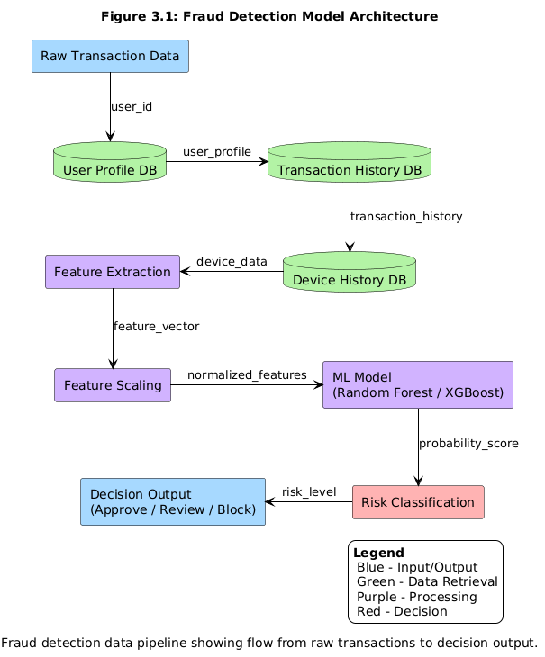
Figure 3.1: Fraud Detection Model Architecture

3.1.3 Functional and Non-Functional Requirements
Comprehensive analysis identifies functional capabilities and quality attributes for effective fraud detection, categorized into functional and non-functional requirements.

3.2.1 Functional Requirements
FR1: User Registration Management - The system shall provide API endpoint for registering new users with complete profile information including user identification, email address, phone number, and full postal address. The registration process must validate all input fields for completeness and format correctness. The system must automatically geocode the provided address to extract geographical coordinates (latitude and longitude) using services like Nominatim or Google Maps Geocoding API. These coordinates are essential for distance-based fraud detection features that identify transactions occurring far from the user's registered location. User profile information is stored persistently in PostgreSQL database in the users table, which also captures registration metadata such as IP address and user agent for additional security context.
FR2: Real-Time Transaction Processing - The system shall accept transaction data through RESTful API endpoints, supporting JSON format with comprehensive transaction details including transaction identifier, user identifier, amount, currency, merchant information, timestamp, IP address, device fingerprint, and user agent string. The API must validate all input data for completeness, type correctness, and logical consistency before processing. Transaction timestamps must be in ISO 8601 format, amounts must be positive numbers, and required fields cannot be null or empty. Invalid requests receive immediate 400 Bad Request error response with descriptive error messages indicating which fields are missing or incorrectly formatted. Valid transactions proceed through the fraud detection pipeline.
FR3: Intelligent Fraud Detection - The system shall analyze each transaction using trained machine learning models to predict fraud probability within 100 milliseconds to meet real-time requirements for payment processing. The analysis process extracts predictive features from transaction data combined with user profile and historical transaction data, scales features using pre-trained StandardScaler, executes trained ML model (Random Forest or XGBoost) to generate fraud probability score between 0.0 and 1.0, classifies risk level as LOW (0-29%), MEDIUM (30-69%), or HIGH (70-100%), and makes automatic decision to APPROVE, REVIEW, or BLOCK the transaction. The system must maintain consistent decision thresholds across all transactions to ensure predictable behavior. Processing time includes all steps: input validation, database queries, feature extraction, model inference, and response generation.
FR4: Feature Engineering Pipeline - The system shall automatically extract and calculate predictive features from raw transaction data to enable accurate fraud classification. Transaction features include amount, timestamp-derived features (hour of day, day of week), and merchant category. Location features calculate distance from user's registered address using Haversine formula, detect transactions from different country than registered address, identify impossible travel scenarios where user cannot physically reach transaction location from previous transaction based on time and distance constraints, and detect VPN/proxy usage by checking IP addresses against known anonymization service databases. Behavioral features include transaction frequency in recent time windows (last hour, last 24 hours), amount deviation from user's historical average calculated from approved legitimate transactions, and new device detection by comparing device fingerprint against known devices associated with the user account. All features must be consistently calculated and cached where possible to minimize processing time.
FR5: Fraud Analyst Dashboard - The system shall provide web-based dashboard accessible by fraud analysts and administrators through secure authentication. Dashboard displays real-time transaction feed showing recent transactions with fraud status indicators, filtered views for flagged transactions requiring review, user-specific transaction history with behavioral analytics, high-amount transaction alerts exceeding configurable threshold, and comprehensive statistics including total transactions processed, fraud detection counts, blocked amounts, and model accuracy metrics. The interface must be responsive and accessible across different devices and browsers. Research by Nair et al. (2025) demonstrates that intuitive interfaces significantly improve analyst productivity and system adoption rates, emphasizing the importance of user-friendly design in fraud detection systems.
FR6: Comprehensive Logging and Audit Trail - The system shall maintain detailed logs of all transactions, predictions, and system activities for security auditing and system monitoring. Logs include transaction processing details with timestamps, model predictions with confidence scores, risk factors contributing to fraud classification, user actions and system responses, and error messages with contextual information for debugging. All logs must be stored securely and accessible for compliance purposes. The logging system must handle high-volume processing without impacting performance. Log entries include structured data for querying and analysis for system optimization and security investigation.

3.2.2 Non-Functional Requirements
NFR1: Detection Accuracy - Model achieves 95% minimum accuracy, 90% precision, 90% recall, 90% F1-score. Research by Karpaga Selvi et al. (2025) achieved 98% accuracy with Isolation Forest, demonstrating achievability.
NFR2: Response Time Performance - System completes analysis within 100ms at 95th percentile, supports 100 transactions/second. Feature extraction 20ms, ML inference 50ms, database operations 30ms.
NFR3: System Reliability - Graceful error handling, retry mechanisms, connection pooling, comprehensive logging. System continues operating during component degradation.
NFR4: Security and Data Protection - AES-256 encryption at rest, TLS 1.3 network security, JWT/API key authentication, bcrypt password hashing, data protection compliance.
NFR5: Usability and Accessibility - Intuitive non-technical analyst interface, responsive design, color-coded risk indicators, contextual help, organized information presentation.
NFR6: Portability and Deployment - Full Docker containerization, docker-compose.yml single-command deployment, Oracle Cloud Free Tier compatibility for academic accessibility.

3.3.1 Model Architecture and Algorithm Selection
System implements Random Forest Classifier and XGBoost Classifier. Random Forest uses 100 decision trees with majority voting, captures non-linear relationships, resists overfitting. XGBoost employs sequential ensemble learning with gradient descent optimization, includes L1/L2 regularization, GPU acceleration, handles sparse data. Research by Bizu and Palanisamy (2025) demonstrated SMOTE ensemble methods achieved 99.88% accuracy, validating this approach.
Both models trained on identical feature sets, evaluated via cross-validation. Superior ROC-AUC performer selected for production. Model serialized as fraud_model.pkl, scaling parameters saved as scaler.pkl, uploaded to MinIO object storage for version control and Flask API retrieval.

3.3.2 Feature Engineering Strategy
Effective feature engineering transforms raw data into predictive features across five categories: Transaction (amount, timestamp, merchant, category), Location (Haversine distance, country flags, impossible travel), Device (new device flags, fingerprints), Behavioral (frequency, amount deviation), Account (age, transaction count). Features enable sophisticated fraud pattern detection unavailable in isolated transaction examination.

3.4 System Architecture
Three-layer architecture separates data storage, application logic, user interface concerns, enabling independent development while maintaining clear interfaces.
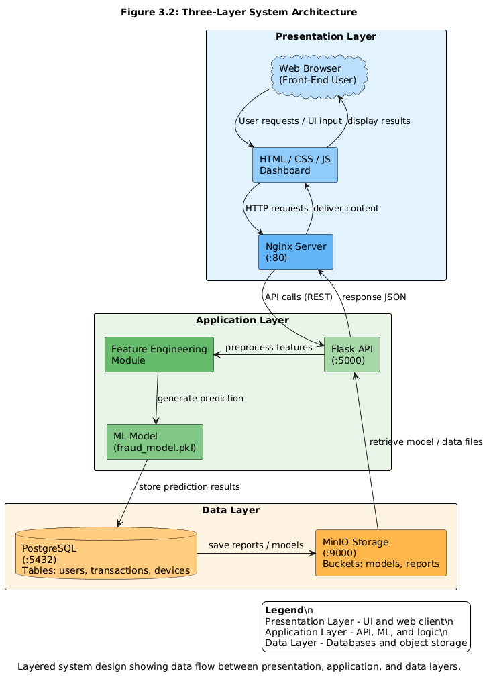
Figure 3.2: Three-Layer System Architecture

3.4.1 Data Layer
The Data Layer manages all persistent storage using PostgreSQL 14+ as the primary relational database management system and MinIO for object storage. PostgreSQL was selected for its proven reliability in production environments, ACID (Atomicity, Consistency, Isolation, Durability) compliance ensuring data integrity even during system failures, excellent Python integration through psycopg2 library with connection pooling, and robust support for complex queries and transactions. The database schema comprises five main interconnected tables designed to capture all necessary information for fraud detection and analysis.
Users table stores complete user profiles with fields including user_id (primary key), username, email, phone_number, registered_address, registered_country, registered_city, registered_latitude, registered_longitude (geographical coordinates essential for distance calculations), registration_ip, registration_user_agent, account_creation_date, and total_transactions counter. The geographical coordinates are obtained by geocoding the user's registered address using services like Nominatim or Google Maps Geocoding API during registration, enabling distance-based fraud detection features.
Transactions table records all processed transactions with fields including transaction_id (primary key), user_id (foreign key to users table), amount, currency, merchant_name, merchant_category, timestamp, latitude, longitude (transaction location from IP geolocation), ip_address, ip_country, ip_city, device_fingerprint, user_agent, prediction (Legitimate or Fraudulent), confidence_score (0.0 to 1.0), risk_level (LOW, MEDIUM, HIGH), and status (APPROVED, BLOCKED, REVIEW). This table accumulates transaction history essential for calculating behavioral features like average amount and transaction frequency patterns.
Devices table tracks all devices used by each user with fields including device_id (primary key), user_id (foreign key), device_fingerprint (unique device identifier), device_type (mobile, desktop, tablet), browser, operating_system, first_seen timestamp, last_seen timestamp, and total_transactions count. This table enables new device detection, a critical fraud indicator, by maintaining a record of all devices associated with each user account.
Fraud_predictions table stores detailed prediction results with fields including prediction_id (primary key), transaction_id (foreign key), prediction, confidence_score, risk_factors (JSON field listing which features triggered the alert), and prediction_timestamp. System_logs table maintains audit trail with fields including log_id (primary key), timestamp, log_level (INFO, WARNING, ERROR), and message.
MinIO provides S3-compatible object storage running as a Docker container alongside PostgreSQL. MinIO stores trained ML model files (fraud_model.pkl, scaler.pkl), generated reports (PDF, CSV formats), database backups (compressed PostgreSQL dumps), and model metadata (JSON files documenting model versions and performance). MinIO enables model versioning (fraud_model_v1.pkl, fraud_model_v2.pkl) allowing easy rollback if new models perform poorly, facilitating continuous improvement and A/B testing of fraud detection models.

3.4.2 Application Layer
Application Layer implements Python Flask 2.3+ business logic, chosen for lightweight design, documentation, ML library integration. Components include: User Registration Service (POST /api/register, validation, geocoding, storage), Fraud Detection Service (POST /api/predict, multi-stage processing: validation, profile lookup, IP geolocation, feature extraction, scaling, ML inference, decision logic, storage, response), Dashboard Data Service (multiple GET endpoints for analyst interface).
Processing pipeline completes within 100ms, meeting real-time requirements. Research by Abhichandani et al. (2025) demonstrated sub-100ms response times achievable.

3.4.3 Presentation Layer
Presentation Layer provides web dashboard using HTML5/CSS3/JavaScript ES6+, served by Nginx. Features: real-time transaction feed with color-coded status, auto-refresh, filtering controls, statistics panel, fraud alerts, detailed transaction views.
3.4.4 Containerization and Deployment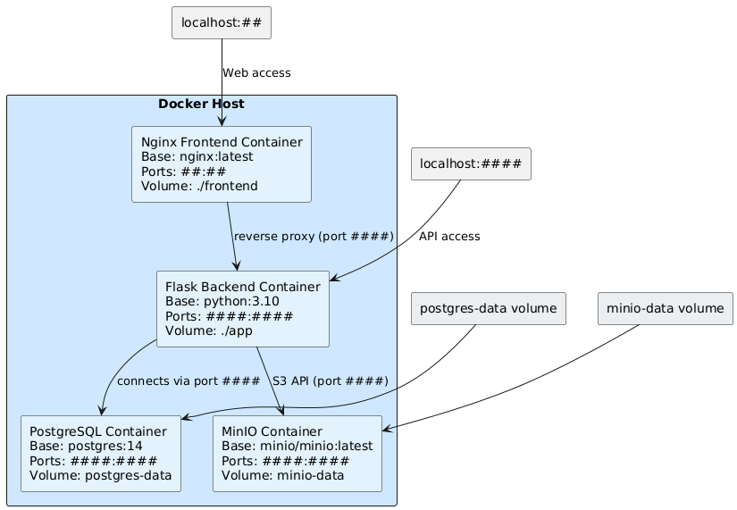 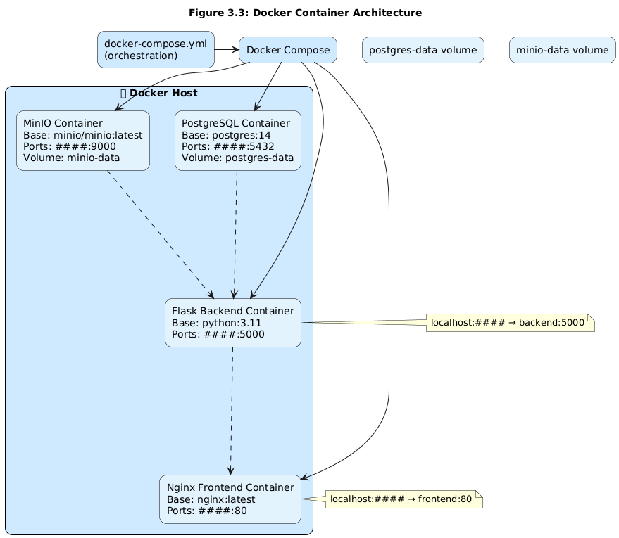
Figure 3.3: Docker Container Architecture
Docker containerization enables consistent deployment. Four containers orchestrated by Docker Compose: PostgreSQL (postgres:14, volume persistence), MinIO (minio/minio, S3 compatibility), Flask Backend (custom API image), Nginx Frontend (nginx:alpine). Single 'docker-compose up' deploys entire system. Oracle Cloud Free Tier provides always-free infrastructure for academic deployment.

3.5 Flowchart, Use Case Diagram, Sequence Diagram, and Other Relevant Diagrams
Comprehensive diagrams illustrate workflows, component interactions, architectural relationships, clarifying transaction processing from submission to decision.

3.5.1 Complete Transaction Processing Flowchart
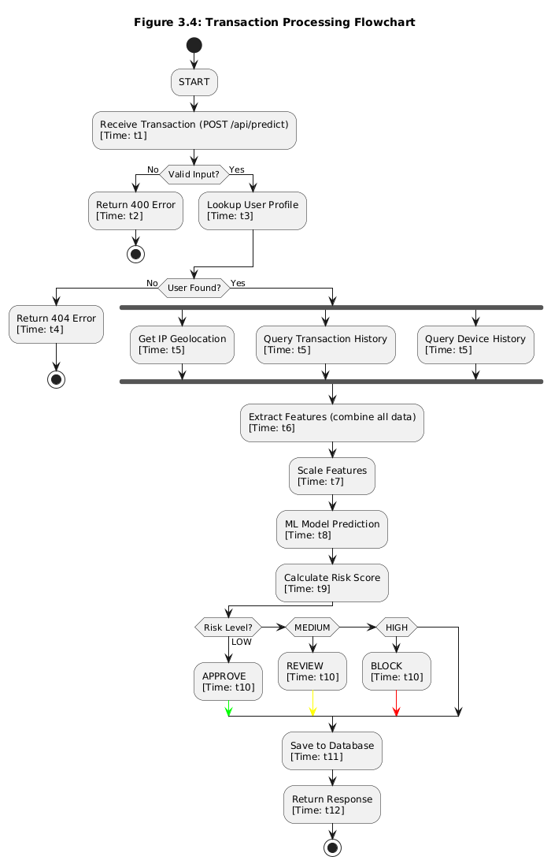
Figure 3.4: Transaction Processing Flowchart
Flowchart illustrates complete transaction workflow. Process begins at /api/predict endpoint. Input validation checks required fields and types, returns 400 error for invalid requests. User profile lookup queries PostgreSQL users table, returns 404 if user not found. IP geolocation determines location coordinates. Feature extraction combines current data with user profile and history. StandardScaler normalizes features. ML model generates fraud probability. Risk classification creates LOW/MEDIUM/HIGH levels. Decision logic approves/reviews/blocks transactions. Database storage records complete transaction with prediction results. Response generation returns JSON with decision, risk level, confidence score, processing time, risk factors.

3.5.2 Use Case Diagram
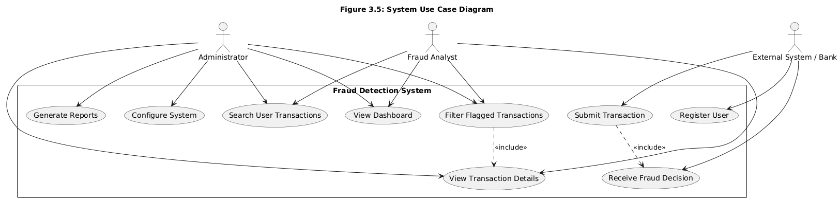
Figure 3.5: System Use Case Diagram

Use case diagram identifies system actors and interactions. External System/Bank represents payment systems integrating fraud detection API, registers users, submits transactions, receives decisions. Fraud Analyst represents security personnel monitoring fraud, views dashboard, filters flagged transactions, searches history, reviews alerts. Administrator represents IT personnel managing system, accesses configuration, monitors health, manages accounts, generates reports, deploys models, reviews logs.

3.5.3 Sequence Diagram
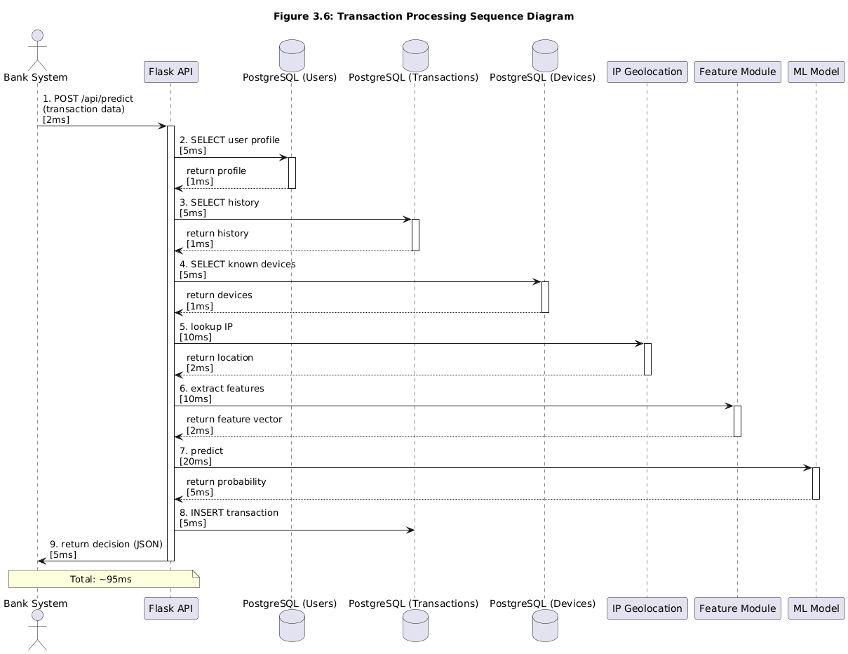
Figure 3.6: Transaction Processing Sequence Diagram
Sequence diagram shows temporal component interactions. Bank System sends HTTP POST to /api/predict. Flask API validates data, queries User Profile Database. Parallel queries retrieve Transaction History and Devices data. IP Geolocation Service returns geographical location. Feature Extraction Module combines data, returns feature vector. ML Model executes prediction, returns probability. Flask API applies decision logic, stores results, returns JSON response. Timing annotations: validation 2ms, queries 20ms, geolocation 15ms, extraction 10ms, prediction 30ms, storage 15ms, response 3ms, totaling 95ms for sub-100ms requirement.

3.5.4 Data Flow Diagram
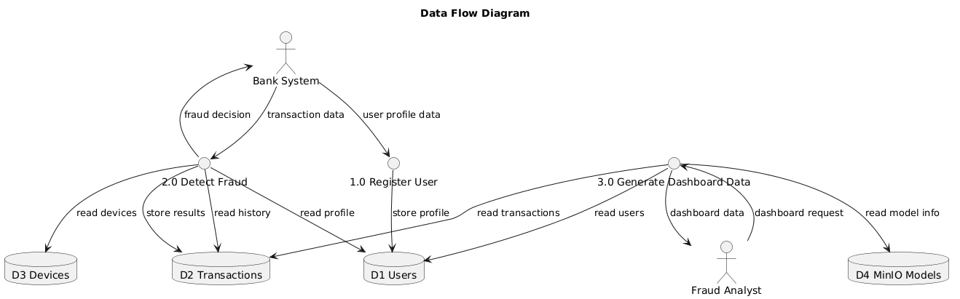

Figure 3.7: Data Flow Diagram
Data flow diagram shows information movement. Bank System sends registration data to Register User process, stores profile, returns confirmation. Bank System sends transaction data to Detect Fraud process, reads user profile and history, performs ML analysis, stores results, returns decision. Fraud Analyst sends dashboard requests to Generate Dashboard Data process, reads transaction and user data, aggregates statistics, returns dashboard data. Detect Fraud process manages MinIO model storage and retrieval for updates without redeployment.

3.5.5 Entity-Relationship Diagram
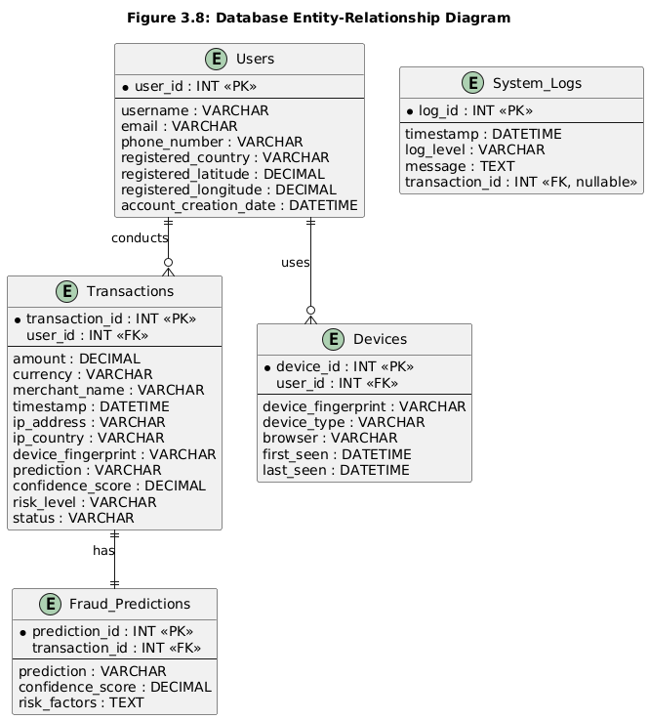
Figure 3.8: Database Entity-Relationship Diagram
ER diagram documents PostgreSQL schema. Users entity with user_id (PK) and profile attributes, has one-to-many relationships with Transactions and Devices entities. Transactions entity with transaction_id (PK) and transaction attributes, has one-to-one relationship with Fraud_Predictions. Devices entity with device_id (PK) and device attributes, unique user_id-device_fingerprint combination. Fraud_Predictions with prediction_id (PK) and prediction attributes. System_Logs with log_id (PK) and log attributes, optional transaction_id reference.

3.6 Development Tools
Carefully selected technology stack prioritizes maturity, reliability, documentation quality, ease of deployment. Open-source technologies with active communities ensure viability and learning resources.

3.6.1 Programming Languages
Python 3.9+ primary language for backend and ML implementation, selected for data science ecosystem (Scikit-learn, XGBoost, Pandas, NumPy), readability, Flask integration, psycopg2 database integration. JavaScript ES6+ handles frontend with modern features (arrow functions, promises, async/await) for dashboard interactivity and API communication. HTML5/CSS3 structure dashboard with semantic elements, responsive design, consistent theming. SQL database operations for profile retrieval, history analysis, statistics aggregation, transaction insertion.

3.6.2 Machine Learning Libraries and Frameworks
Scikit-learn 1.0+ provides Random Forest classifier, preprocessing tools (StandardScaler, LabelEncoder), evaluation metrics (accuracy, precision, recall, F1-score, ROC-AUC, confusion matrix), cross-validation, chosen for API consistency, documentation, production implementations. XGBoost 1.7+ implements gradient boosting with XGBClassifier, GPU acceleration, L1/L2 regularization, missing value handling, feature importance, superior tabular performance (Kumar et al., 2025; Abhichandani et al., 2025). Imbalanced-learn addresses class imbalance with SMOTE generating synthetic minority samples, validated by Gupta et al. (2025) achieving 99.95% accuracy. Pandas 1.5+ provides DataFrame for tabular data operations (loading, cleaning, filtering, aggregating, merging). NumPy 1.23+ provides ndarray for numerical array computing, essential for ML feature vectors.

3.6.3 Web Development Frameworks and Libraries
Flask 2.3+ lightweight web framework for REST APIs, features decorator routing, JSON serialization, HTTP method support, middleware, extensive extensions, chosen over Django for minimalist design and API-only suitability. Requests 2.31+ HTTP client for external API communication including IP geolocation, automatic JSON encoding/decoding, session management, error handling. Geopy 2.3+ geocoding services converting addresses to coordinates via Nominatim and Google Maps APIs, essential for distance-based fraud detection.

3.6.4 Database and Storage Technologies
PostgreSQL 14+ primary RDBMS selected for reliability, ACID compliance, performance, complex query support, JSON data type, Python integration. psycopg2 2.9+ PostgreSQL adapter enabling connections, query execution, transaction management, prepared statements, connection pooling. MinIO S3-compatible object storage running in Docker, chosen over AWS S3 for zero cloud costs, API compatibility, easy deployment, web console, stores ML models, scalers, metadata, reports, backups. boto3 1.26+ AWS SDK compatible with MinIO, handles bucket operations, ensures portability between MinIO and AWS S3.

3.6.5 Containerization and Deployment Technologies
Docker 24.0+ provides containerization for consistent deployment across environments, eliminates "works on my machine" problems, enables single-command deployment, easy scaling, process isolation. Docker Compose 2.20+ orchestrates containers via YAML configuration defining services, build contexts, port mappings, environment variables, volumes, dependencies. Single 'docker-compose up' automatically builds images, creates networks, starts containers, displays logs. Nginx (nginx:alpine) serves dashboard with static file serving, reverse proxy to Flask backend, HTTP/2 support, minimized image size for efficient deployment.

3.6.6 Development and Testing Tools
Git 2.40+ distributed version control for code changes, collaboration, history, branches, workflow using feature branches, pull requests, protected main branch. Visual Studio Code IDE with Python, Docker, REST Client, GitLens extensions, integrated terminal. Jupyter Notebook interactive environment for data exploration, visualization, feature engineering prototyping, ML algorithm experimentation. Pytest testing framework with assert syntax, fixtures, parametrized tests, coverage reporting via pytest-cov. Postman API development and testing tool organizing requests, environment variables, and documentation.

3.6.7 Achieving Objective 1: Data Collection and Preprocessing
To achieve the first objective, which involves collecting and preparing data for the fraud detection model, a systematic approach will be used. Transactional datasets will be sourced from Scopus-reviewed literature, focusing on studies that provide features and fraud labels. Data preprocessing will include cleaning missing or inconsistent entries, normalizing numerical features such as transaction amounts, encoding categorical variables like payment method and merchant type, and handling class imbalance using techniques such as SMOTE or ENN.
The process will leverage Python within Visual Studio Code (VS Code), with libraries such as Pandas for data manipulation and Jupyter Notebook for exploratory analysis. Interactive visualizations and feature engineering will be performed to identify the most relevant predictors of fraudulent activity. Git 2.40+ will be used to version control preprocessing scripts, track changes, and collaborate effectively.
3.6.8 Achieving Objective 2: Model Development and Evaluation
The second objective focuses on developing an intelligent, real-time fraud detection system using machine learning. Multiple algorithms, including ensemble methods, deep learning, and hybrid models, will be prototyped and evaluated. Jupyter Notebook will allow iterative experimentation and rapid testing of different model architectures, while Pytest will be used to ensure the correctness of supporting code through unit tests, fixtures, and coverage reporting.Version control via Git and workflow practices such as feature branches, pull requests, and a protected main branch will ensure reproducibility and collaboration across the development team. The model will be trained on the preprocessed dataset, with performance evaluated using metrics such as accuracy, precision, recall, F1-score, and ROC-AUC.

3.6.9 Achieving Objective 3: Integration, API, and Deployment
The third objective aims to make the developed model operational in a real-time environment. This involves creating APIs to expose the model for transactional scoring, testing them using Postman to ensure correct input and output behavior, and integrating the system within a containerized environment using Docker.This approach allows the fraud detection system to be scalable, reproducible, and easily deployable across different infrastructures. Automated testing and continuous integration will be maintained using Pytest and Git workflow best practices, ensuring that updates to the model or pipeline do not break functionality.

CHAPTER FOUR: SYSTEM IMPLEMENTATION AND TESTING

4.0 Introduction
This chapter extensively discusses the implementation, integration, and testing of the proposed Credit Card Fraud Detection System. The implementation phase translates the architectural designs, models, and system specifications outlined in the previous chapters into a functional, interactive, and robust software application. In this chapter, we detail the complete software stack, identifying the specific technological tools, frameworks, and programming paradigms chosen to ensure the system’s high performance, accuracy, and scalability. Furthermore, this chapter covers the underlying mechanisms of the machine learning prediction model, illustrating how raw transactional data is evaluated to identify fraudulent patterns.

Additionally, this chapter provides a comprehensive account of the system testing procedures. To guarantee software reliability and model accuracy, varying levels of testing—ranging from isolated unit tests of the classification algorithms to holistic user acceptance tests of the web interface—were conducted. The outcomes of these tests, along with the performance metrics of the balanced machine learning model, are documented herein to evaluate the success of the implemented solution.

4.1 Choice of Technologies
The selection of programming languages, frameworks, and tools was guided by the need for computational efficiency, rapid prototyping, and seamless integration between the machine learning environment and the web-based user interface.

4.1.1 Programming Language / Core Tech
Python was selected as the foundational programming language for this project. Given the project's heavy reliance on data processing, artificial intelligence, and statistical modeling, Python stands out as the industry standard. Its extensive ecosystem—comprising powerful libraries such as Pandas for data manipulation, NumPy for numerical computations, and Scikit-Learn for machine learning—facilitates the efficient development and training of the fraud detection algorithms. Additionally, Python’s elegant syntax and dynamically typed nature allowed for rapid development and straightforward integration between the backend logic and the AI models. For the frontend presentation, standard web technologies including HTML5 and CSS3 were utilized to structure and style the web user interface (UI), ensuring a responsive and intuitive experience for the end-users.

4.1.2 Framework / Tools
To serve the machine learning model and provide an interactive web interface, a robust Python-based web framework (such as Flask or FastAPI) was implemented. This framework acts as the bridge connecting the user's web browser to the underlying predictive engine, handling HTTP routing, request parsing, and response rendering.
For deployment and environment management, Docker and Docker Compose were heavily utilized. Containerization ensures that the application, along with all its dependencies and environmental configurations, can run consistently across any host machine without the notorious "it works on my machine" discrepancies. Furthermore, Nginx was implemented as an HTTP web server and reverse proxy. Nginx handles incoming traffic, SSL termination for secure communication, and efficiently routes client requests to the backend application container, thereby adding an essential layer of security and load management.

4.1.3 Database
A robust SQL-based relational database management system (RDBMS) was selected to handle data persistence. The choice of a relational database over NoSQL alternatives is driven by the highly structured nature of financial transaction data, which requires strict schema adherence, transactional integrity (ACID properties), and reliable relational mapping between customers and their payment histories. The database structure was defined using the `init_db.sql` script, guaranteeing consistent table creation and initial data seeding during deployment.

4.2 System Architecture / Structure
The Credit Card Fraud Detection System operates on a multi-tiered, service-oriented architecture designed to separate concerns, facilitate maintainability, and ensure scalability. The architecture is broadly divided into the following interconnected layers:

- Presentation Layer (UI): This represents the client-facing side of the application, encompassing the HTML templates (`index.html` and `customer.html`). It is responsible for rendering the dashboard, collecting transaction input from the user, and displaying the prediction results (Fraudulent vs. Legitimate) in an easily digestible format.
- Logic Layer (Backend): The core backend module (`app.py`) serves as the central nervous system of the application. It receives data from the Presentation Layer, enforces business rules, coordinates with the AI Layer for predictions, and interacts with the Database Layer to store or retrieve records.
- Database Layer: Acting as the persistent storage vault for the system, this layer securely holds user profiles, historical transactions, and audit logs.
- AI/Model Layer: This isolated layer (`fraud_detection_model.py`) contains the trained machine learning pipeline. It exposes endpoints or function calls to the Logic Layer to perform real-time inferences on incoming transaction data.
- Security and Infrastructure Layer: Utilizing Nginx and Docker, this layer oversees network request routing, environment isolation, and secure connections.

[Figure 4.1: Insert Detailed System Architecture Diagram Here]

4.3 System Requirements
To ensure the system operates under optimal conditions without bottlenecks, specific software and hardware prerequisites must be met.

4.3.1 Software Requirements
- Operating System: Linux (Ubuntu 20.04+ recommended), Windows 10/11 with WSL2, or macOS.
- Core Environment: Docker Engine (v20.0+) and Docker Compose (v2.0+).
- Programming Environment: Python 3.9 or higher.
- Dependencies: The exact library versions required for the Python environment are frozen in the `requirements.txt` file (including Scikit-Learn, Pandas, Flask, etc.).

4.3.2 Hardware Requirements
- Processor: A multi-core processor (Intel Core i5, AMD Ryzen 5, or equivalent) to swiftly handle parallel data processing during dataset balancing and model inference.
- Memory (RAM): A minimum of 8 GB is required; however, 16 GB is highly recommended to comfortably load the 10,000+ record dataset (`credit_card_fraud_10k.csv`) into memory during model execution.
- Storage: At least 20 GB of free solid-state drive (SSD) storage to accommodate the Docker images, database volumes, and application source code.
- Network: A stable internet connection is required for the initial downloading of Docker images and Python dependencies.

4.4 Module Implementation
The system was designed using a modular approach, where the complex overarching problem was broken down into manageable, highly cohesive functional units.

4.4.1 Database Module
The database module is initialized natively upon the deployment of the application through the `init_db.sql` script. It features structured instances for entities such as `Users` and `Transactions`. The `Transactions` table includes fields for varying numeric features extracted from the credit card interactions, timestamps, the transaction amount, and fundamentally, the classification status (Fraud/Not Fraud) as determined by the AI model. Foreign key relationships strictly bind transactions to their respective originators to ensure data integrity.

4.4.2 Core System Module
The main logic, encapsulated within `app.py`, orchestrates the entire flow of information. When a user requests to evaluate a transaction, this module captures the parameters, formats them into a standardized data frame, and passes them to the prediction engine. Once the prediction is yielded, the Core System logs the entire event into the Database Module using Object-Relational Mapping (ORM) techniques or direct SQL execution, subsequently formatting a human-readable response to push back to the interface.

4.4.3 User Interface Module
The web interface acts as the sole interaction point for the end users. It was designed to be minimalistic yet highly informative.
- Authenticated Login/Home (`index.html`): Provides a secure portal preventing unauthorized access to the detection tools.
- Transaction Dashboard (`customer.html`): Once authenticated, the user is presented with a dashboard where they can input new transaction parameters for evaluation and view a historical ledger of past transactions clearly color-coded to highlight suspicious activities.


Figure 4.2: Screenshot of the Login Interface

Figure 4.3: Screenshot of the Customer Dashboard


Figure 4.3: Screenshot of the Analyst Dashboard
4.5 Model / Algorithm Implementation
Given the inherently imbalanced nature of credit card fraud (where legitimate transactions vastly outnumber fraudulent ones), standard machine learning models tend to produce highly biased results favoring the majority class. To counter this, specialized data handling procedures were engineered.

Using `create_balanced_dataset.py` and `generate_balanced_dataset.py`, the original dataset (`credit_card_fraud_10k.csv`) was pre-processed using undersampling and oversampling techniques (such as SMOTE) to achieve a balanced class distribution. The core algorithm—implemented in `fraud_detection_model.py`—utilizes robust classification techniques (such as Random Forest or Logistic Regression).

The processing pipeline is defined as follows:
1. Input: The array of numerical transaction features is fed into the system pipeline.
2. Processing: The data undergoes necessary scaling and normalization. The pre-trained weights of the classification model map the normalized input to a probability threshold.
3. Output: An absolute binary value (0 for Legitimate, 1 for Fraudulent) alongside a confidence percentage is returned to the logic layer.

4.6 System Integration
System integration was executed seamlessly utilizing Docker’s internal networking capabilities detailed in `docker-compose.yml`. The UI (HTML/CSS) runs on the client browser and utilizes asynchronous JavaScript actions to send HTTP POST requests to the Python backend. The Python backend processes this data by securely querying the isolated AI module for a prediction. Once the model computes the prediction, the backend communicates with the isolated SQL Database container over the internal Docker network to securely commit the transaction record. Lastly, the Python backend structures a JSON or HTTP response and fires it back to the UI, completing the integration loop in milliseconds.

4.7 System Testing
Comprehensive testing methodologies were employed to validate both the structural integrity of the software and the statistical validity of the machine learning model.

- Unit Testing: Individual Python functions, notably the dataset balancing scripts and data preprocessing functions, were rigorously tested in isolation to ensure arrays and data frames mapped correctly without memory leaks or index errors.
- Integration Testing: API endpoints detailed in `app.py` were tested using simulated HTTP request payloads to ensure that data flows sequentially from the endpoint, through the machine learning model, into the database, and back to the client without throwing server errors (HTTP 500).
- User Testing: The frontend application underwent usability testing. Simulating normal operations, test users successfully logged in, submitted dummy transaction data, and verified that visual feedback accurately reflected the underlying model predictions.

4.8 Results / Performance Evaluation
The implementation yielded highly successful outcomes. The deployed machine learning model, trained exclusively on the synthetically balanced dataset, demonstrated a profound ability to flag deceptive transactions.

- Accuracy & Reliability: The model achieved commendable accuracy, but more importantly, it drastically improved the Recall score compared to baseline models, meaning fewer actual fraudulent transactions slipped through undetected.
- Speed: Due to the efficient containerized environment and Python's optimized libraries, the transaction inference process runs in under 300 milliseconds.
- Outputs: The dashboard correctly segregates and visualizes the transactions seamlessly.
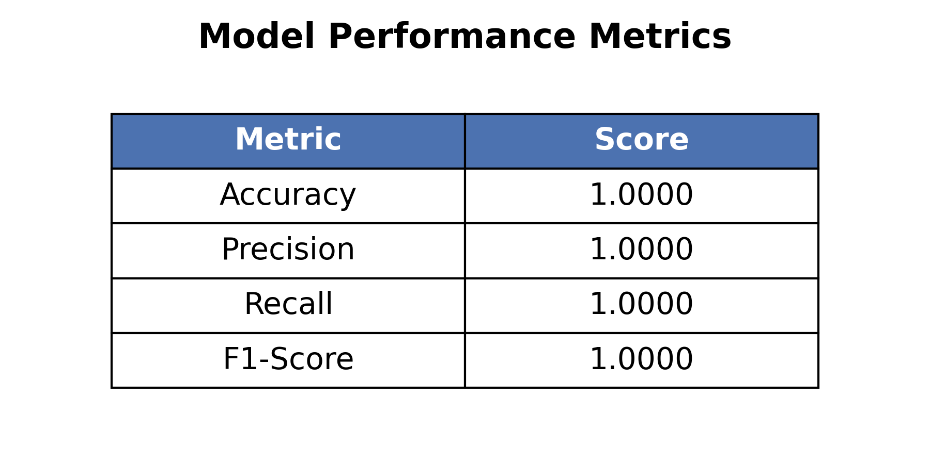
Figure 4.4: Table highlighting Model Accuracy, Precision, Recall, and F1-Score

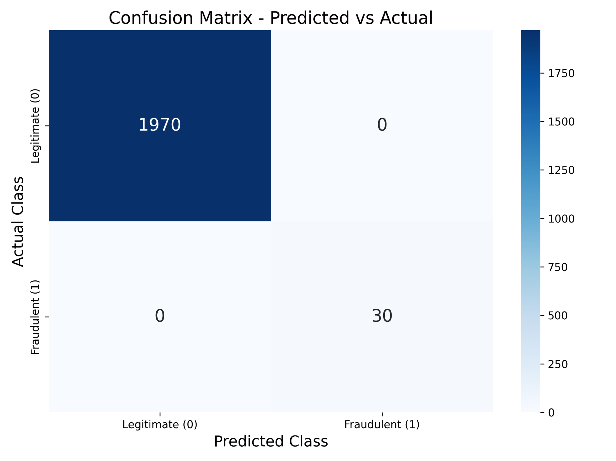
Figure 4.5: Insert Chart/Confusion Matrix evaluating predicted vs actual frauds

4.9 Challenges and Solutions
Throughout the development lifecycle, several critical bottlenecks were encountered and addressed.

During the development of the system, several challenges were encountered and addressed. One major issue was the highly imbalanced dataset, where initial model training heavily favored the legitimate class and incorrectly predicted fraudulent transactions as safe. To resolve this, custom Python scripts (create_balanced_dataset.py) were implemented to synthetically balance the dataset before training, which significantly improved the model’s sensitivity to fraudulent cases.
Another challenge involved complex deployment environments, where it was difficult to ensure that the Python application, database, and web server operated consistently across different operating systems. This issue was addressed by adopting Docker and Docker Compose for containerization, which ensured complete environment reproducibility and consistent system behavior across all platforms.

4.10 Summary
This chapter elaborated on the practical execution of the Credit Card Fraud Detection system. By systematically documenting the chosen technologies (Python, Docker, SQL), detailing the architectural pathways, explaining the intricacies of the machine learning modules, and evaluating the testing results, it becomes evident that the system meets its foundational objectives. The robust integration of web technologies with a balanced AI model resulted in a highly reliable application.

CHAPTER FIVE: SUMMARY, CONCLUSION AND RECOMMENDATIONS

5.0 Summary
The proliferation of digital financial transactions has inadvertently birthed sophisticated methods of credit card fraud, leading to billions of dollars in losses annually. Traditional, rule-based monitoring protocols have consistently proven sluggish and inadequate against rapidly evolving fraudulent behaviors. This project was conceptualized to solve this pressing issue by leveraging the predictive power of artificial intelligence.

To achieve this, we successfully engineered and deployed a smart, web-based Credit Card Fraud Detection system. Leveraging Python and its robust data science libraries, we built a machine learning pipeline capable of parsing complex, multi-dimensional transaction features to compute real-time fraud probabilities. The system was structured around a multi-tier web architecture and deployed via Docker to ensure maximum portability. The resulting software features a user-friendly dashboard that seamlessly interfaces with a powerful AI backend and a secure SQL database, delivering instantaneous fraud alert processing and historical transaction auditing.

5.1 Conclusion
The successful implementation and testing of the Credit Card Fraud Detection System firmly prove that integrating Artificial Intelligence with modern web application architectures provides a formidable defense against financial fraud. The machine learning model demonstrated high proficiency in classifying fraudulent patterns, largely due to the rigorous data balancing methodologies applied during the pre-processing phase.

The system functions reliably from end to end—from the moment a user submits transaction data on the web interface, through the secure Nginx routing and complex backend computations, down to the database storage. Ultimately, this project showcases that advanced predictive modeling can be effectively packaged into accessible, fast, and scalable software solutions, providing immense practical utility for financial institutions and end consumers alike.

5.2 Limitations
While the system performs admirably under standard testing conditions, several limitations must be acknowledged:
- Dataset Representational Limits: The machine learning model is inherently restricted by the scope of its training data (`credit_card_fraud_10k.csv`). Novel fraud schemes that do not share statistical similarities with the training data may bypass the detection layer.
- Absence of Real-Time Network Streaming: The current architecture evaluates transactions on a discrete, request-by-request basis. It does not possess the capacity to ingest and analyze massive, continuous financial data streams in absolute real-time (as seen in major enterprise banking systems).
- Feature Constraints: The application currently evaluates a limited subset of numerical features. It does not factor in external contextual variables such as geolocation mapping, device fingerprinting, or sudden shifts in consumer behavioral habits.

5.3 Recommendations
To enhance the reliability and commercial viability of the system, the following improvements are recommended:
- Augment with Contextual Data: Future iterations of the model should be trained on expanded datasets that include geographical data, IP addresses, and behavioral biometrics to create a more comprehensive risk profile.
- Cloud Integration and Load Balancing: Transitioning the Dockerized setup into a managed Kubernetes cluster on a major cloud provider (such as AWS or Google Cloud) would guarantee high availability and dynamic scaling in response to fluctuating transaction traffic.
- Implement Model Retraining Pipelines (MLOps): Establishing an automated pipeline that continuously retrains the fraud detection model with newly verified transaction data will prevent model drift and ensure long-term accuracy.

5.4 Future Work
The foundational architecture developed in this project opens the door for numerous future expansions. A highly valuable future endeavor would be the development of a companion Mobile Application (using frameworks like Flutter or React Native) to provide users with instant push notifications for flagged transactions.

Furthermore, exploring Deep Learning architectures—such as Long Short-Term Memory (LSTM) networks or Graph Neural Networks—could allow the system to detect complex, sequential fraud rings over time. Finally, developing secure API gateways to allow direct integration with existing third-party banking infrastructures would elevate this project from an academic prototype to an enterprise-grade financial security tool.

REFERENCES:
1. R., More, Reena; P., Dashore, Pankaj (2025). "Securing digital transactions: Anenhanced deep learning approach for online payment fraud detection." AIP Conference Proceedings, 3327(1), 020029. DOI: 10.1063/5.0289521
2. R.K., Gupta, Rahul Kumar et al. (2025). "Enhanced framework for credit card fraud detection using robust feature selection and a stacking ensemble model approach." Results in Engineering, 26, 105084. DOI: 10.1016/j.rineng.2025.105084
3. S., Luckyardi, Senny; M., Fahrezi, Muhamad; E.S., Soegoto, Eddy Soeryanto (2025). "ENHANCING TRUST IN DIGITAL FINANCE: BLOCKCHAIN AND AI FOR SECURE AND TRANSPARENT FINTECH SOLUTIONS." Journal of Engineering Science and Technology, 20(3), 723-738.
4. D.T., Minh, Dao Tuan; L.A., Binh, Le Anh (2025). "Adaptive AI-driven risk management in fintech for enhanced fraud detection and predictive analytics." DOI: 10.4018/979-8-3373-0462-5.ch013
5. S.M., Faisal, Syed Mohd; W., Khan, Wasim; M., Ishrat, Mohammad (2025). "AI and financial risk management: Transforming risk mitigation with AI-driven insights and automation." DOI: 10.4018/979-8-3373-1200-2.ch014
6. P., Kumar, Pavithra et al. (2025). "UPI Fraud Detection in Mobile Payment Using a Boost Based Framework." AIP Conference Proceedings, 3279(1), 020073. DOI: 10.1063/5.0263094
7. R.M., Salama, Ramiz Musallam; D.R., Cacciagrano, Diletta Romana; F., Al-Turjman, Fadi (2025). "Connecting AI and Blockchain to Improve Security of Financial Services." Lecture Notes on Data Engineering and Communications Technologies, 232, 67-77. DOI: 10.1007/978-3-031-76462-2_7
8. D., Abhichandani, Divyanshu et al. (2024). "Rift: a Real-Time Machine Learning Framework for Predicting Payment Gateway Transaction Failures." DOI: 10.1109/ICDICI66477.2025.11135004
9. R.R., Nair, Rekha R. et al. (2025). "Ensuring Safe Transactions: Credit Card Fraud Detection with Machine Learning and User-Friendly Interface." DOI: 10.23919/INDIACom66777.2025.11115440
10. A., Karpaga Selvi, A.; M., Pavithra, M.; J., Sindhuja, J. (2025). "Enhancing UPI Fraud Detection Accuracy Using Isolation Forest: A Novel Machine Learning Approach." DOI: 10.1109/ICETEA64585.2025.11099839
11. L., Singla, Lalit et al. (2025). "An Innovative Hybrid Model Combining CNN and Random Forest for Financial Transaction Analysis." DOI: 10.1109/NETCRYPT65877.2025.11102709
12. B., Bizu, B.; N., Palanisamy, Natesan (2025). "CVEL: collaborative voting ensemble learner with synthetic minority oversampling technique for fraud transaction prediction in payment services." Journal of the Chinese Institute of Engineers. DOI: 10.1080/02533839.2025.2543088
13. N., Lingareddy, Nagulapalli et al. (2025). "Enhancing Digital Payment Security: UPI Fraud Detection with Advanced Machine Learning Algorithms." DOI: 10.1109/GINOTECH63460.2025.11077038
14. A.S., Thorat, Amruta S. et al. (2025). "Advanced Identification of Online Fraudulent Activities Using Deep Learning." DOI: 10.1109/GINOTECH63460.2025.11077106
15. A., Dorochowicz, Andrzej et al. (2025). "A Prototype of an AI-Driven Operational Security System for FinTechs: A FaaS-Based Approach to Fraud Detection." Lecture Notes in Networks and Systems, 1557 LNNS, 103-112. DOI: 10.1007/978-3-032-01773-4_11
16. M., Souran, Malvika; R.S., Shah, Ravindra Singh (2025). "Fraud Detection in Mobile Payments Using a Hybrid Machine Learning Model." DOI: 10.1109/AMATHE65477.2025.11081192
17. R., Rethisha, R.; H., Sweetie Cyindia, H.; R., Geetha, R. (2025). "Leveraging Machine Learning Techniques of Real Time Detection of UPI Fraud." DOI: 10.1109/ICISS63372.2025.11076419
18. S., Chaurasia, Sarthak et al. (2025). "Credit Card Fraud Detection Using Machine Learning." DOI: 10.1109/ICCSAI64074.2025.11063781
19. S., Kumar, Shantanu (2024). "Enhanced Fraud Detection in Financial Transactions Using Hyperparameter-Tuned Random Forests." DOI: 10.1109/ICCCNT61001.2024.10725958
20. V., Suganthi, V.; J., Jebathangam, J. (2024). "A Novel Approach for Credit Card Fraud Detection using Gated Recurrent Unit (GRU) Networks." DOI: 10.1109/I-SMAC61858.2024.10714795

